1. To install all libraries : pip install -r requirements.txt
2. To run server : python app.py
3. From React: Send a post request to : http://127.0.0.1:5000/colorDetect

In body: send an array of images with name: file

Example:

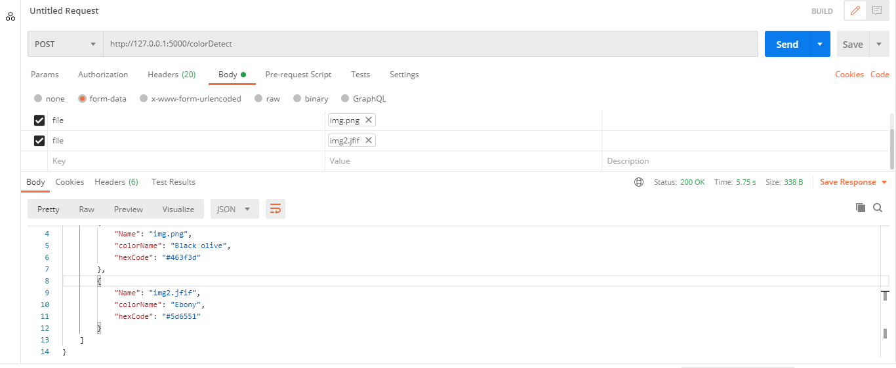

This is the response you will get :

{

    "results": [

        {

            "Name": "img.png",

            "colorName": "Black olive",

            "hexCode": "#463f3d"

        },

        {

            "Name": "img2.jfif",

            "colorName": "Ebony",

            "hexCode": "#5d6551"

        }

    ]

}